Yuva Intern. - Week 1 Project Plan

Week 1 task : Comprehensive project plan

Student Name: Sanjay V P

Project Title:Smart E-commerce customer behaviour & Sales prediction system using python

1. Introduction & Background
This is a hypothetical E-Commerce Customer Behavior & Sales Prediction project. The main problem is high cart abandonment and low repeat purchases. We plan to use Python to predict which customers will purchase based on their behavior.

2. Motivation and Justification
A 5% increase in customer retention can increase business profit by 25-95%. This project is technically relevant as it covers the full Python data science lifecycle and is highly scalable to other domains like telecom and banking.

3. Objectives & Scope
Objectives: To define hypothetical data schema, design cleaning and EDA strategy, propose ML models for purchase prediction, and plan deployment.
In-Scope: Complete planning, architecture design, timeline of 35 hours, tool selection.
Out-of-Scope: Actual coding, real dataset training, and live deployment (for Week 1).
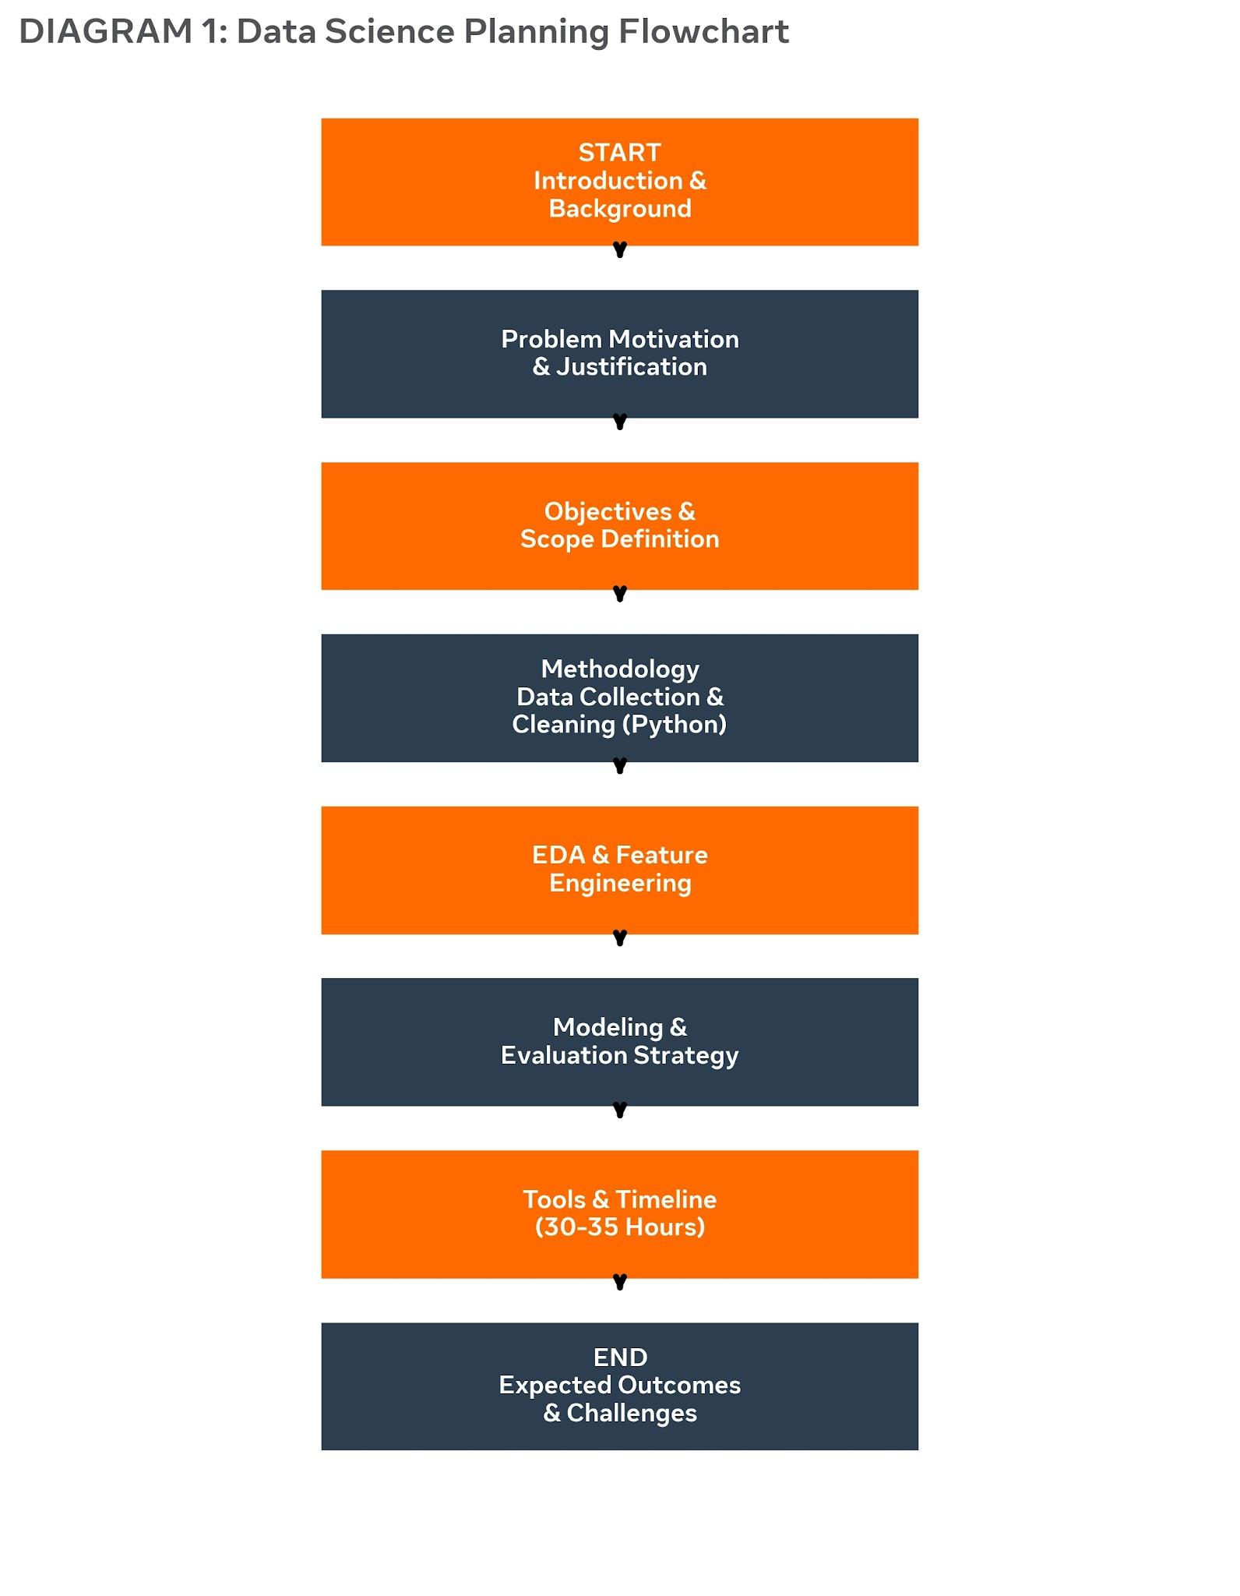
4. Methodology & Strategy (CRISP-DM). - Data Collection (Hypothetical): CustomerID, Age, Session Duration, Cart Value, Previous Purchases, Purchase (0/1) using Faker library.
- Data Cleaning: Handling missing values with SimpleImputer, outlier removal with IQR, encoding with OneHotEncoder using Pandas & NumPy.
- EDA: Distribution analysis, correlation heatmap, RFM analysis using Matplotlib & Seaborn.
- Modeling: Segmentation (K-Means), Classification (Logistic Regression, Random Forest, XGBoost).
- Evaluation: Accuracy, Precision, Recall, F1-Score, ROC-AUC with 5-Fold Cross-Validation.
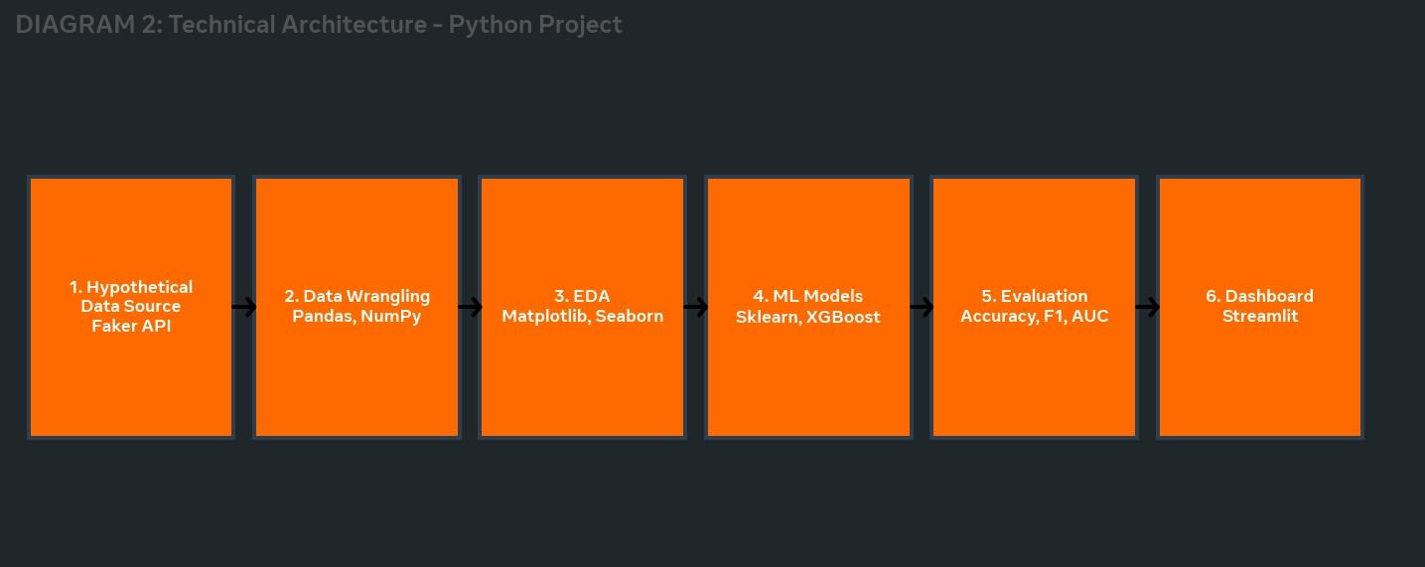
5. Timeline (30-35 Hours)
Introduction & Background - 5h, Motivation - 4h, Objectives & Scope - 4h, Methodology - 8h, Diagrams - 5h, Tools & Timeline - 4h, Expected Outcomes & Challenges - 5h. Total = 35 Hours.
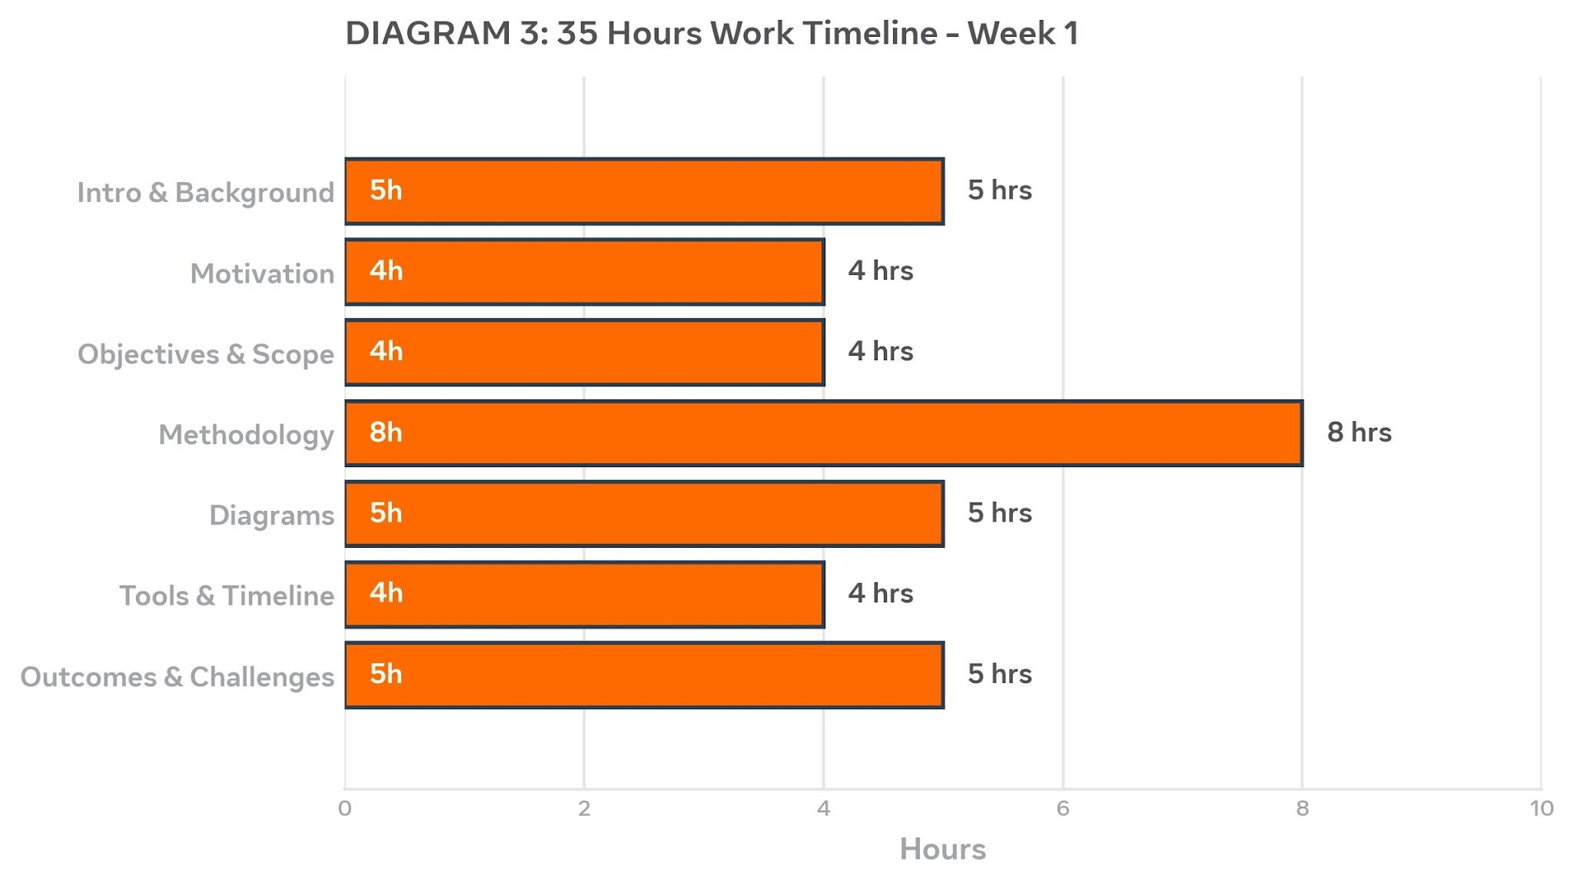
6. Tools and Technology
Python, Pandas, NumPy, Matplotlib, Seaborn, Scikit-Learn, XGBoost, Faker, Streamlit, Jupyter Notebook, Git & GitHub.

7. Expected Outcomes & Challenges
Outcomes: A ready-to-implement project plan, expected accuracy of 88-92%, business benefits like 20% reduction in cart abandonment.
Challenges: Data Imbalance (15% purchase) - Mitigation: Use SMOTE; Hypothetical Bias - Mitigation: Diverse Faker profiles.

